**“Experiment 1.3”**

Student Name: **SUMIT KUMAR** UID: **20BCS8226**

Branch: **CSE** Section/Group: **MM-808-A**

Semester: **05** Date of Submission: **05/09/22**

Subject Name: **Competitive Coding Lab** Subject Code: **20CSP-314**

**Aim/Overview of the practical:**

**Question 1: Compare two linked lists**

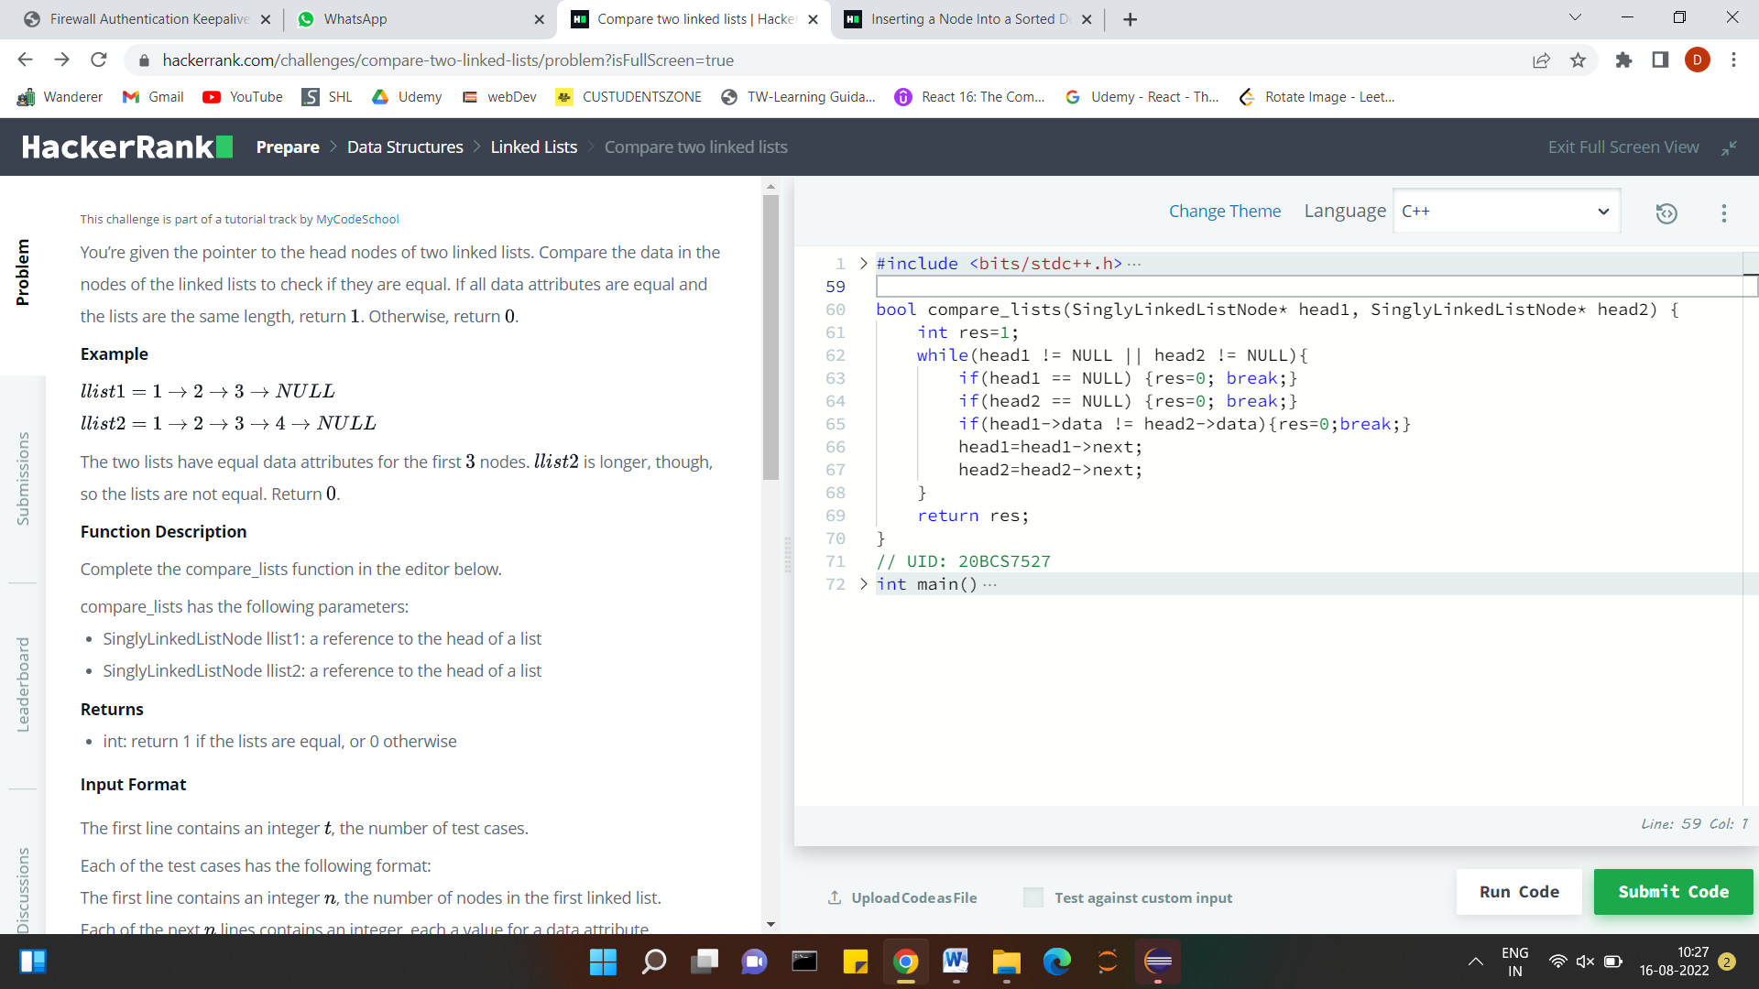

**Question 2: Inserting a Node Into a Sorted Doubly Linked List**

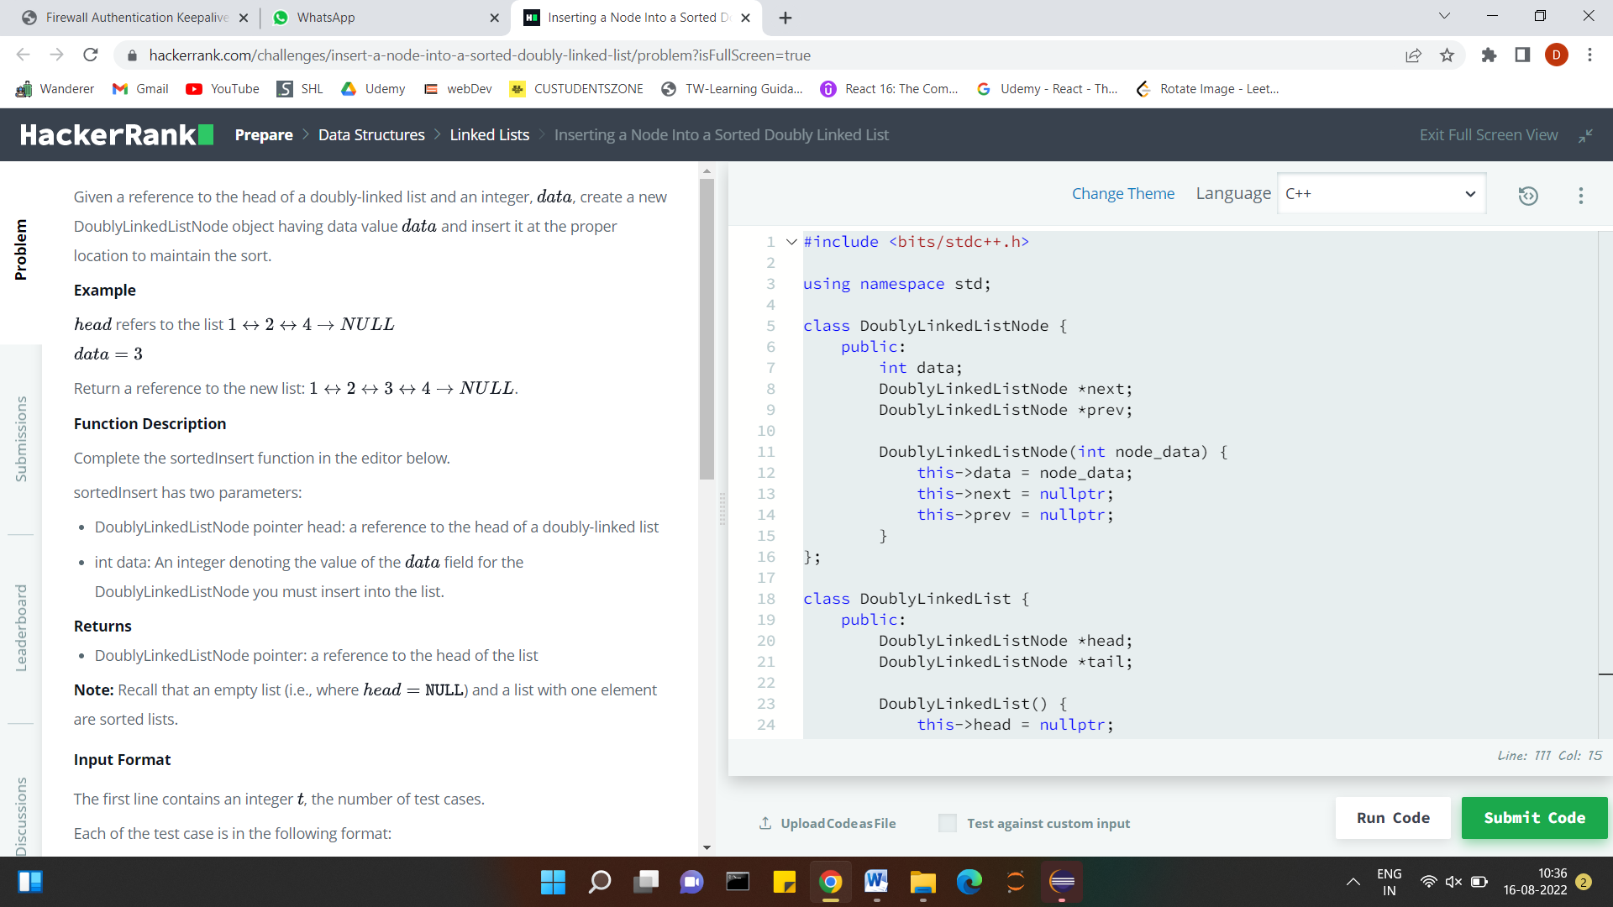

**Steps for experiment/practical/Code:**

**Question 1 Code:**

#include <bits/stdc++.h>

using namespace std;

class SinglyLinkedListNode {

    public:

        int data;

        SinglyLinkedListNode *next;

        SinglyLinkedListNode(int node_data) {

            this->data = node_data;

            this->next = nullptr;

        }

};

class SinglyLinkedList {

    public:

        SinglyLinkedListNode *head;

        SinglyLinkedListNode *tail;

        SinglyLinkedList() {

            this->head = nullptr;

            this->tail = nullptr;

        }

        void insert_node(int node_data) {

            SinglyLinkedListNode* node = new SinglyLinkedListNode(node_data);

            if (!this->head) {

                this->head = node;

            } else {

                this->tail->next = node;

            }

            this->tail = node;

        }

};

void print_singly_linked_list(SinglyLinkedListNode* node, string sep, ofstream& fout) {

    while (node) {

        fout << node->data;

        node = node->next;

        if (node) {

            fout << sep;

        }

    }

}

void free_singly_linked_list(SinglyLinkedListNode* node) {

    while (node) {

        SinglyLinkedListNode* temp = node;

        node = node->next;

        free(temp);

    }

}

bool compare_lists(SinglyLinkedListNode* head1, SinglyLinkedListNode* head2) {

    int res=1;

    while(head1 != NULL || head2 != NULL){

        if(head1 == NULL) {res=0; break;}

        if(head2 == NULL) {res=0; break;}

        if(head1->data != head2->data){res=0;break;}

        head1=head1->next;

        head2=head2->next;

    }

    return res;

}

// UID: 20BCS8226

int main()

{

    ofstream fout(getenv("OUTPUT_PATH"));

    int tests;

    cin >> tests;

    cin.ignore(numeric_limits<streamsize>::max(), '\n');

    for (int tests_itr = 0; tests_itr < tests; tests_itr++) {

        SinglyLinkedList* llist1 = new SinglyLinkedList();

        int llist1_count;

        cin >> llist1_count;

        cin.ignore(numeric_limits<streamsize>::max(), '\n');

        for (int i = 0; i < llist1_count; i++) {

            int llist1_item;

            cin >> llist1_item;

            cin.ignore(numeric_limits<streamsize>::max(), '\n');

            llist1->insert_node(llist1_item);

        }

        SinglyLinkedList* llist2 = new SinglyLinkedList();

        int llist2_count;

        cin >> llist2_count;

        cin.ignore(numeric_limits<streamsize>::max(), '\n');

        for (int i = 0; i < llist2_count; i++) {

            int llist2_item;

            cin >> llist2_item;

            cin.ignore(numeric_limits<streamsize>::max(), '\n');

            llist2->insert_node(llist2_item);

        }

        bool result = compare_lists(llist1->head, llist2->head);

        fout << result << "\n";

    }

    fout.close();

    return 0;

}

**Question 2 Code:**

#include <bits/stdc++.h>

using namespace std;

class DoublyLinkedListNode {

    public:

        int data;

        DoublyLinkedListNode *next;

        DoublyLinkedListNode *prev;

        DoublyLinkedListNode(int node_data) {

            this->data = node_data;

            this->next = nullptr;

            this->prev = nullptr;

        }

};

class DoublyLinkedList {

    public:

        DoublyLinkedListNode *head;

        DoublyLinkedListNode *tail;

        DoublyLinkedList() {

            this->head = nullptr;

            this->tail = nullptr;

        }

        void insert_node(int node_data) {

            DoublyLinkedListNode* node = new DoublyLinkedListNode(node_data);

            if (!this->head) {

                this->head = node;

            } else {

                this->tail->next = node;

                node->prev = this->tail;

            }

            this->tail = node;

        }

};

void print_doubly_linked_list(DoublyLinkedListNode* node, string sep, ofstream& fout) {

    while (node) {

        fout << node->data;

        node = node->next;

        if (node) {

            fout << sep;

        }

    }

}

void free_doubly_linked_list(DoublyLinkedListNode* node) {

    while (node) {

        DoublyLinkedListNode* temp = node;

        node = node->next;

        free(temp);

    }

}

DoublyLinkedListNode* sortedInsert(DoublyLinkedListNode* head, int data) {

  DoublyLinkedListNode* node = new DoublyLinkedListNode(data);

  node->data = data;

  node->next = node->prev = NULL;

  if(head==NULL)

   return node;

 if(head->data > data){

     head->prev = node;

     node->next = head;

     return node;

 }

 DoublyLinkedListNode* next = sortedInsert(head->next, data);

 head->next = next;

 next->prev = head;

 return head;

}

// UID: 20BCS8226

int main()

{

    ofstream fout(getenv("OUTPUT_PATH"));

    int t;

    cin >> t;

    cin.ignore(numeric_limits<streamsize>::max(), '\n');

    for (int t_itr = 0; t_itr < t; t_itr++) {

        DoublyLinkedList* llist = new DoublyLinkedList();

        int llist_count;

        cin >> llist_count;

        cin.ignore(numeric_limits<streamsize>::max(), '\n');

        for (int i = 0; i < llist_count; i++) {

            int llist_item;

            cin >> llist_item;

            cin.ignore(numeric_limits<streamsize>::max(), '\n');

            llist->insert_node(llist_item);

        }

        int data;

        cin >> data;

        cin.ignore(numeric_limits<streamsize>::max(), '\n');

        DoublyLinkedListNode* llist1 = sortedInsert(llist->head, data);

        print_doubly_linked_list(llist1, " ", fout);

        fout << "\n";

        free_doubly_linked_list(llist1);

    }

    fout.close();

    return 0;

}

**Result/Output/Writing Summary:**

**Question 1 Output:**

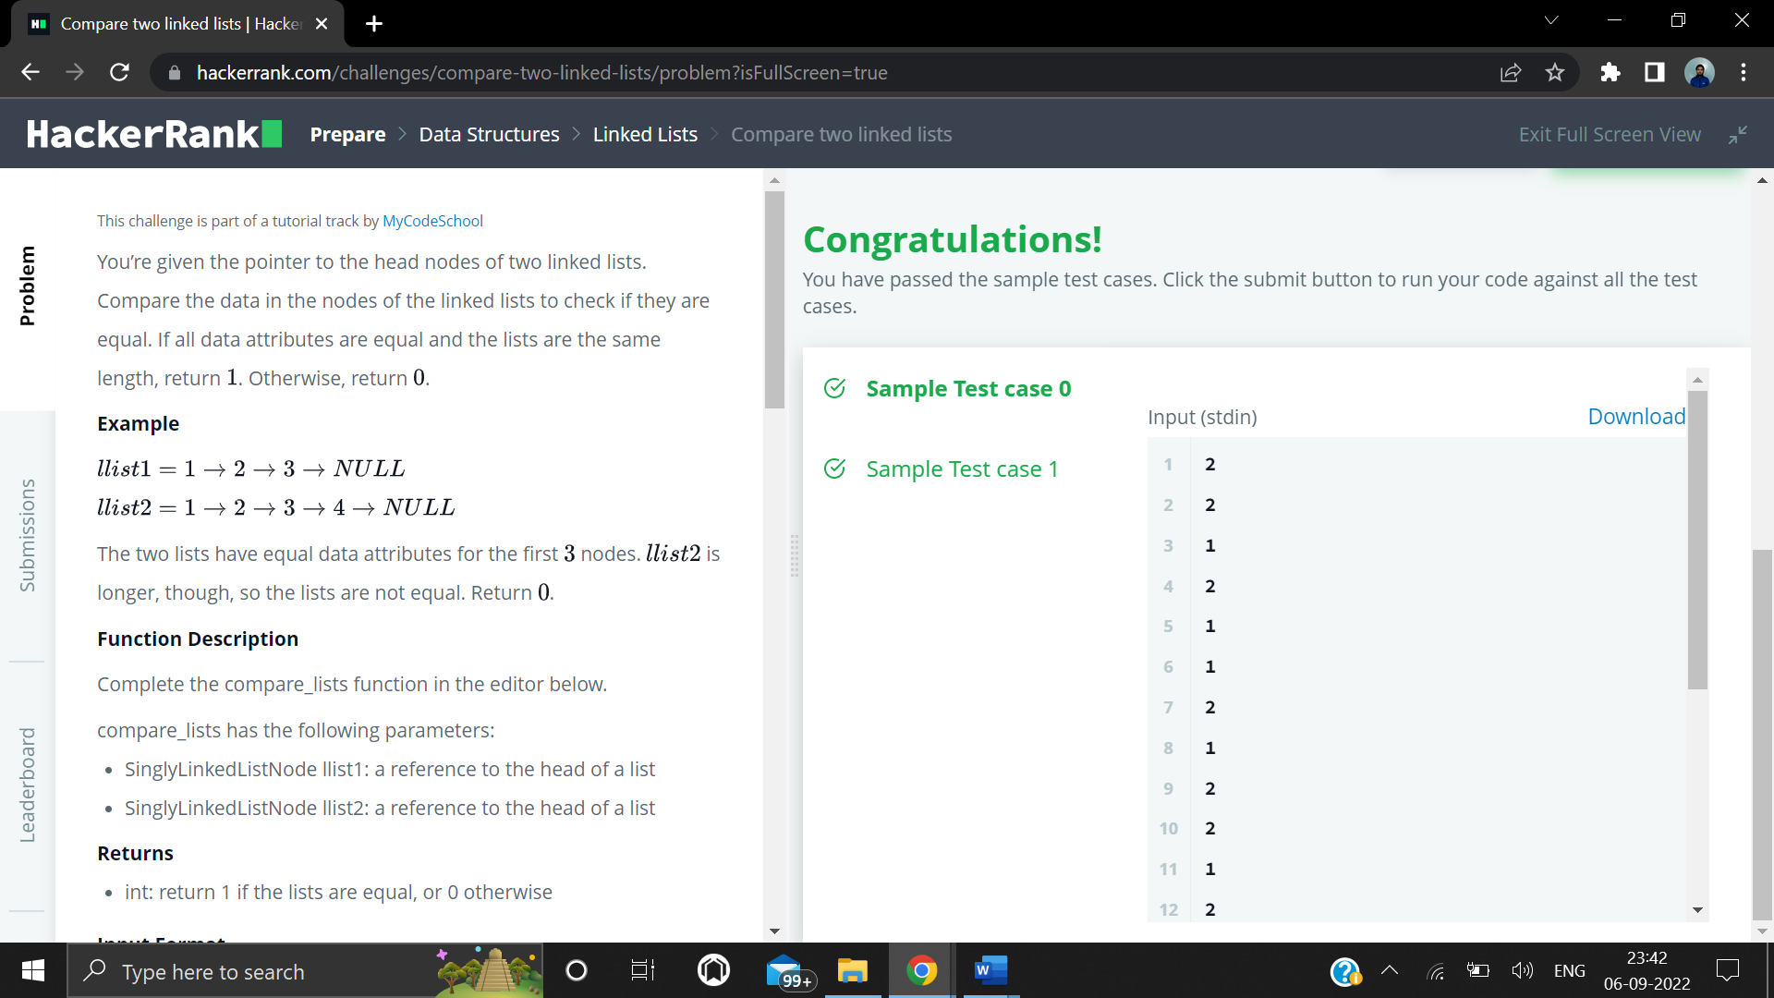

**Question 2 Output:**

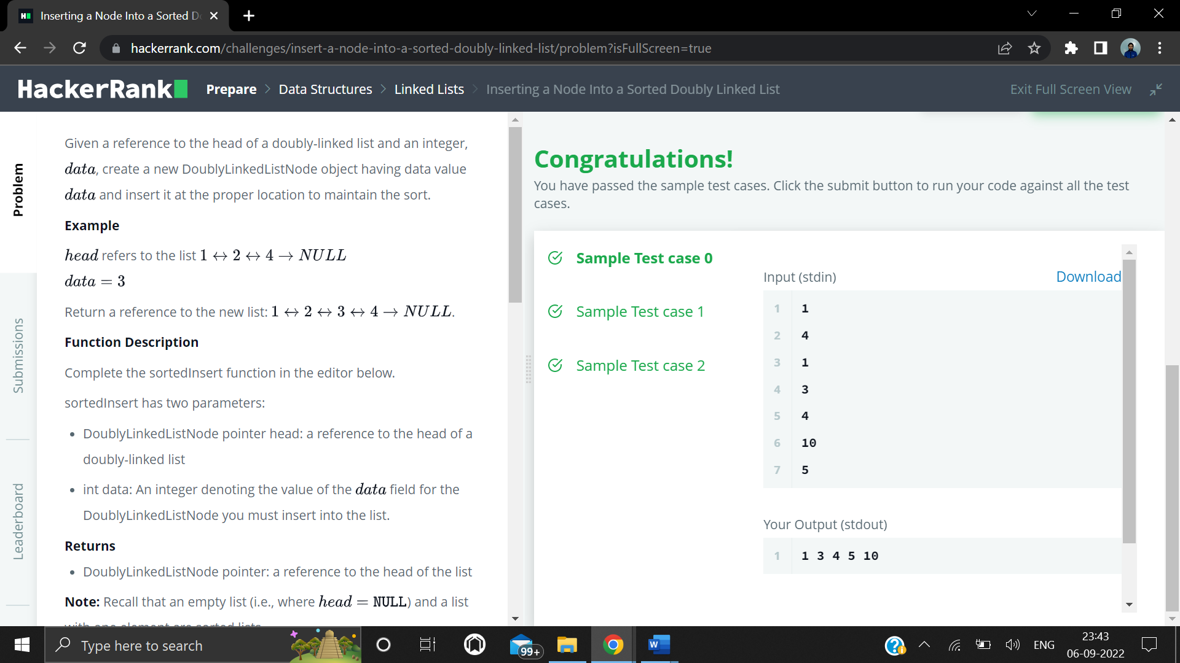

**Learning outcomes (What I have learnt):**

1. **Implementation of linked list.**

**Evaluation Grid (To be created as per the SOP and Assessment guidelines by the faculty):**

|  |  |  |  |
| --- | --- | --- | --- |
| Sr. No. | Parameters | Marks Obtained | Maximum Marks |
| 1. |  |  |  |
| 2. |  |  |  |
| 3. |  |  |  |
|  |  |  |  |